**Mental Health Prediction Using Machine Learning**

### A PROJECT REPORT

#### Submittedby

**NAME OF THE CANDIDATE(S)**

Nimit Garg 21BCS4626

Reyaan Sachdeva 21BCS5381

#### in partial fulfillment for the award of the degree of

**Bachelor’s of Engineering**

###### IN

**Computer Science with specialization in IOT**



###### Chandigarh University

APRIL 2024



**BONAFIDE CERTIFICATE**

Certified that this project report **“Mental Health Prediction Using Machine Learning”** is the bonafide work of “**Nimit Garg , Reyaan Sachdeva”** who carried out the project work under my/our supervision.

###### SIGNATURE

**Aman Kaushik**

###### **HEAD OF THE DEPARTMENT**

###### **AIT-CSE(IOT)**

###### SIGNATURE

###### Mr. Ankur Sharma

###### SUPERVISOR

###### AIT-CSE

Submitted for the project viva-voce examination held on **30th April 2024.**

INTERNAL EXAMINER EXTERNAL EXAMINER

**TABLE OF CONTENTS**

List of Figures 5

List of Tables 6

List of Standards…………………………………………………………………………..7

Abstract 8

Graphical Abstract 9

Abbrevations 10

CHAPTER 1. INTRODUCTION 11

* 1. Identification of Client/ Need/ Relevant Contemporary issue 11
  2. Identification of Problem 12
  3. Identification of Tasks 13
  4. Timeline 16
  5. Organization of the Report 19

CHAPTER 2. LITERATURE REVIEW 22

* 1. Timeline of the reported problem 22
  2. Existing Solutions 24
  3. Bibliometric analysis 26
  4. Problem Definition 28
  5. Goals/Objectives 29

CHAPTER 3. DESIGN FLOW/PROCESS 30

* 1. Evaluation & Selection of Specifications/Features 30
  2. Design Constraints 34
  3. Analysis of Features and finalization subject to constraints 36
  4. Design Flow 39
  5. Design selection 41
  6. Methodology…………………………………………………………………………….43

CHAPTER 4. RESULTS ANALYSIS AND VALIDATION 46

3.1. Implementation of solution 46

CHAPTER 5. CONCLUSION AND FUTURE WORK 61

* 1. Conclusion 61
  2. Future work 63

REFERENCES 67

APPENDIX 70

1. Plagiarism Report 39

# List of Figures

Figure 3.1…………………… Features Analysis & Finalization of Specifications

Figure 3.2 ……………………………………………..Design Flow of the Project

Figure 3.3 ………………………………………………...Methodology of Project

Figure 4.1…………………………………………………………PHQ-9 Datasets

Figure 4.2……………………………...Depression Level Prediction using PHQ-9

Figure 4.3………………………………………Correlation Matrix of PHQ-9 Data

Figure 4.4…………………………………………………………….SAS Datasets

Figure 4.5………………………………………………………..SAS-SV Box plot

Figure 4.6………………….……Smartphone Addiction Predicting using SAS-SV

Figure 4.7………………………..……….Correlation Matrix of SAS-SV datasets

# 

# List of Tables

Table 3.1 …………………………………………Reliability Analysis of PHQ-9 Data

Table 3.2 ………………………………………..Reliability Analysis of SAS-SV Data

### List of Standards (Mandatory For Engineering Programs)

|  |  |  |  |
| --- | --- | --- | --- |
| **Standard** | **Publishing**  **Agency** | **About the standard** | **Page no** |
| IEEE  802.11 | IEEE | IEEE 802.11 is part of the IEEE 802 set of local area network (LAN) technical standards and specifies the set of media access control (MAC) and physical layer  (PHY) protocols for implementing wireless local area network (WLAN) computer communication. | Mention page nowhere standard is used |

# ABSTRACT

# Depression and anxiety in particular continue to be major obstacles for college students dealing with mental health difficulties. This population uses smart phones extensively, therefore there’s a rising interest in learning more about the connection between usage patterns and the impact on mental health. The purpose of this research is to evaluate depression and anxiety symptoms in college students by utilizing machine learning techniques and data gathered from many characteristics, such as mental health indicators and smart phone use. The study’s data set include social, mobile phone usage trends, and demographic information. measures for engagement and well- being gathered from college students. Our particular area of research is the prediction of scores on three commonly used mental health rating scales: the Generalized Anxiety Disorder-7 (GAD-7), the Patient Health Questionnaire-9 (PHQ-9), and Smart phone Addiction Scale - Short Version (SAS-SV). We employ machine learning algorithms, such as Support Vector Machine (SVM), Random Forest, and Gaussian Naive Bayes, to predict SAS, PHQ-9, and GAD-7 scores from the given data set in order to meet our objectives. Measures of social engagement, anxiety/stress levels, and general well-being are among the tools used to train these models. The purpose of the study is to gather data regarding the association between college students’ smart phone usage habits and mental health outcomes. We attempt to find potential trends and connections between mobile phone usage patterns and indicators of mental health by evaluating the data and utilizing machine learning techniques. The results of this study can guide the creation of focused interventions and support plans meant to enhance the well being of students. In summary, this study advances knowledge of the intricate relationship between college students’ smart phone use and mental health consequences. Our goal is to extract meaningful insights from machine learning approaches that might drive evidence-based interventions and direct future research to enhance student mental health.

**ABBREVIATIONS**

# 

# SAS-SV: Smart phone Addiction Scale - Short Version

# PHQ-9: Patient Health Questionnaire-9

# GAD-7: Generalized Anxiety Disorder 7-item scale

# SVM: Support Vector Machines

# ROC: Receiver Operating Characteristic

# EDA: Exploratory Data Analysis

# Cronbach's Alpha: A measure of internal consistency reliability

## **CHAPTER 1: INTRODUCTION**

### 1.1.Identification of Client /Need / Relevant Contemporary issue

**Identification of Client:**

This study's main focus is on university instructors and students from a range of academic fields. Students face a variety of social, intellectual, and personal obstacles at universities, which act as miniature versions of society. For this group, mental health frequently becomes the most important factor to consider in the midst of the demands of social connections, academic success, and personal development.   
  
Students in universities are more vulnerable to mental health issues because of the transitional period they go through. Higher stress, anxiety, and depression can result from the transition from youth to adulthood, as well as from the demands of school and the increased independence that comes with it. However, despite their greater experience, faculty members might still face similar difficulties because they have their own unique set of obligations in terms of teaching, research, and administration.

The mental health of instructors and students is extremely important because of the significant influence that colleges have on the development of future generations. Making sure they are psychologically well not only helps them succeed academically but also creates a positive learning atmosphere and enhances their general well being. Therefore, in order to improve support networks and intervention techniques, this research aims to offer customized insights into the dynamics of mental health within university communities.

With university communities being multifaceted, this study attempts to offer a comprehensive view of mental health dynamics across many demographic groupings. The research aims to create comprehensive solutions that address the many requirements of the university community by concentrating on both students and faculty, thereby fostering a more positive and encouraging learning environment.

**Identification of Need:**

There has never been a greater demand for better mental health assistance in university settings. A concerning number of university students are reportedly experiencing mental health problems, with many citing symptoms of stress-related diseases, anxiety, and depression. This is supported by recent surveys and research. Long wait times, restricted access, and fragmented care are common outcomes of traditional mental health services' inability to keep up with rising demand, despite growing awareness and advocacy efforts.

There have been notable shifts in the mental health landscape among university populations, which calls for innovative methods of assessment and intervention. Recent research shows that mental health problems are becoming more prevalent, with many students expressing symptoms of anxiety, depression, and other psychological diseases. Conventional techniques for evaluation and assistance frequently fall short, either because of a lack of funding, stigma, or prompt solutions.

This lack of access to mental health care highlights the urgent need for creative, adaptable, and customized solutions that can meet the wide range of changing needs of university communities. In this sense, the field of machine learning and data analytic offers an intriguing frontier: it is possible to use enormous volumes of data to find patterns, forecast results, and customize treatments to meet the requirements of specific individuals.

This study attempts to overcome the current gaps in mental health care provided in academic settings by utilizing technology. The ultimate goal is to improve the mental health of both teachers and students by creating effective, accurate, and easily accessible tools that can allow proactive interventions, early detection, and individualized care.

**Relevant Contemporary Issue:**

The widespread use of cellphones in today's connected society has completely changed the way we interact, work, and live. Smart phones provide new concerns, especially in terms of mental health, even while they provide never-before-seen levels of ease and connectivity. Stress, anxiety, and other mental health problems can be made worse by the constant onslaught of notifications, the temptation to be online, and the blending of work, education, and personal life.   
  
The relationship between digital technology and mental health is a major modern problem that needs to be carefully examined and addressed. Designing effective coping techniques, therapies, and policies requires an understanding of how cellphones affect mental health as they grow more and more incorporated into our daily lives.

By examining the complex association between smart phone usage habits and mental health indicators among university students and teachers, this study seeks to address this important topic. The research aims to provide light on this intricate interplay in order to guide the creation of focused interventions, educational programme, and policy suggestions that support the development of better digital habits and a more moderation in the use of technology.

This study aims to investigate this complex interaction by looking at the relationship between smart phone usage patterns and indices of mental health among college students and instructors. The goal of the research is to use these links to guide the creation of focused interventions, instructional programme, and policy suggestions that encourage better digital habits and a more moderation in the use of technology.

**1.2. Identification of Problem**

The rapid advancement of digital technology, especially smart phones, has completely changed the way we work, communicate, and engage with the world around us. Even though these developments bring with them a level of convenience and disconnectedness never seen before, they also bring with them a host of new difficulties that negatively impact our mental health, particularly for college students and teachers. Due to the widespread use of smart-phones in educational environments, worries about mental health problems, smart-phone addiction, and general quality of life have grown. This part explores the intricacies of these problems, illuminating the pressing issue that this study attempts to solve.

**1.2.1.The Rise of Smart phone Addiction**

Recent years have seen the rise in worry over smart phone addiction, which is frequently characterized by excessive use, dependency, and withdrawal symptoms. Research indicates that university students are especially vulnerable to this type of addiction because of the demands of their studies, social interactions, and altered lifestyles that come with pursuing a higher degree. Students find it difficult to maintain a good balance between their digital and in-person relationships because of their ongoing need to stay connected, as well as the attraction of social media, online gaming, and instant messaging apps.

**1.2.2.Mental Health Implications**

It is impossible to exaggerate how destructive smart phone addiction is to mental health. Extended periods of screen time, disrupted sleep patterns, less physical exercise, and a greater exposure to negative content on the internet can cause elevated levels of stress, anxiety, depression, and other psychological conditions. These problems have an impact on academic achievement as well as general well-being, interpersonal connections, and quality of life, all of which are declining. Furthermore, people are frequently discouraged from seeking prompt assistance due to the stigma attached to mental health issues, which exacerbates the issue.

**1.2.3.Academic and Social Consequences**

Beyond the personal sphere, educational institutions and society at large may be affected by smart phone addiction and related mental health problems. As a result of these challenges, pupils are more likely to experience absenteeism, worse grades, higher dropout rates, and decreased academic interest. Maintaining a balanced approach to technology use presents issues for faculty members as well, which has an impact on their overall job happiness, productivity, and effectiveness as teachers. To make matters worse, the widespread nature of smart phone addiction can also result in a decline in community involvement, a reduction in social connections, and a feeling of loneliness.

**1.2.4. The Need for Comprehensive Solutions**

Unquestionably, given the complexity of the issue, all-encompassing, empirically supported solutions are required to address the underlying causes and contributing variables of smart-phone addiction and mental health problems. Though they are important, traditional therapies like counselling, psychotherapy, and educational programme frequently fail to reach a wider audience, offer individualized help, and keep up with the quickly changing digital landscape.

**1.2.5. The Role of Predictive Modeling and Data Analytics**

Let us introduce you to the exciting field of predictive modelling and data analytics, which has the potential to completely transform the provision of mental health services in university settings. Using big data analytics, real-time monitoring, and machine learning algorithms, this research intends to create novel solutions that can anticipate future trends, recognize early warning signs, and customize therapies according to the needs and preferences of each individual.

**1.3. Identification of Tasks**

**1. Gathering and preparing data:**

The project's first phase is collecting data from university faculty and students with great care. Creating surveys to gather specific data on demographics, mental health markers, and smart phone usage trends is part of this approach. At this point, ethical issues like informed consent and data privacy are crucial. Thorough pre processing procedures are carried out after data collection to clean, normalize, and encode the variables in preparation for further analysis. The validity and dependability of the study findings are significantly influenced by the quality and integrity of the data set.

1. **Literature Review:**

Conducting a thorough literature evaluation is crucial in order to place the research within the larger context of existing knowledge. This entails a thorough search and examination of books, peer-reviewed journals, and other academic works that are connected to mental health evaluation, predictive modelling, and smart phone addiction. The knowledge gained from the literature is useful for honing the research objectives, choosing acceptable approaches, and pointing out gaps in the field's present understanding. It also helps in the formulation of hypotheses and provide the study's theoretical underpinnings.

1. **Model Selection and Development:**

Appropriate machine learning algorithms are selected for the development of predictive models based on the knowledge gained from the literature review and preliminary

investigations. Algorithms such as Random Forest, Support Vector Machines (SVM), and Neural Networks are assessed according to their interpret ability, availability, and application. The chosen algorithms are then put into practice using R or Python as a programming language, and optimization and hyper parameter adjustment are carefully considered to improve model performance.

1. **Feature Engineering:**

To improve the models' prediction capacity, a crucial process called "feature engineering" entails identifying, removing, and altering pertinent variables from the data set. To find significant patterns, correlations, and interactions between the variables, statistical know-how, domain experience, and sophisticated data analytic technologies are used. To increase the model's resilience and generalization, strategies such feature scaling, dimensional reduction, and feature selection are used.

1. **Model Training and Validation:**

To guarantee robustness and generalization, the selected machine learning models are trained on the prepared data set and their performance is cross-validated. To evaluate how well the models predict mental health outcomes, evaluation metrics such as accuracy, precision, recall, F1-score, and area under the ROC curve are calculated. Finding the optimal model architecture and parameters is made easier by this iterative training and validation procedure.

1. **Performance Evaluation:**

A thorough performance evaluation of the trained models is conducted utilizing a variety of statistical metrics and visualization strategies. To comprehend the advantages and disadvantages of the models, confusion matrices, ROC curves, precision-recall curves, and other diagnostic plots are examined. This thorough assessment offers insightful information on the predictive power, possible biases, and opportunities for development of the models, which directs future improvements and optimization.

1. **Interpretation and Analysis:**

To gain valuable insights into the intricate connections between smart phone usage patterns and mental health markers, the predictive models' output is carefully examined and understood. To find hidden patterns, trends, and correlations in the data, advanced statistical techniques including regression modelling, correlation analysis, and hypothesis testing are used. By clarifying the underlying dynamics and mechanisms impacting mental health outcomes, interpretive analysis hopes to contribute to the scholarly conversation on the topic.

1. **Visualizations and Reporting:**

Graphs, charts, heat maps, info graphics, and other detailed visualizations are used to effectively convey the research findings. With the use of these visual aids, stakeholders, decision-makers, and the general public will be able to comprehend and analyse the complicated data and analysis in a more easily understood manner. A thorough study report that summarizes the methodology, results, discussions, and conclusions is put together and is a great resource for audiences in academia and business.

1. **Ethical Considerations:**

It is crucial to uphold ethical integrity at every stage of the research process. Every step of the study process carefully addresses ethical issues, such as getting participants' informed consent, protecting the privacy and confidentiality of their data, and abiding by institutional and ethical requirements. In addition to protecting the rights and welfare of participants, adhering to ethical standards improves the reliability, validity, and credibility of study findings.

1. **Peer Review and Feedback:**

To guarantee quality, validity, and reliability, the study methods, conclusions, and interpretations are subjected to a rigorous peer review process by professionals in the field. Peers, mentors, and advisers can provide constructive criticism and insightful comments that are very helpful in improving the research design, methods, and interpretations. Peer review advances knowledge and research in the fields of mental health evaluation and predictive modelling by promoting academic rigour, accountability, and transparency.

1. **Recommendations and Future Directions:**

Actionable suggestions and solutions are developed for stakeholders, such as community organizations, policymakers, health care experts, and university administrators, based on the research findings and insights. With the goal of efficiently addressing the difficulties and ramifications of smart phone addiction and mental health concerns, these recommendations are intended to guide the creation of policies, intervention techniques, and the distribution of resources. To encourage more investigation and creativity in the field, future research directions, possible areas for intervention, and chances for multidisciplinary collaboration are also covered.

**1.4. Timeline**

**Phase 1: Preliminary Planning and Literature Review (Weeks 1-4)**

**Week 1:** Finalize research objectives, scope, and hypotheses.

**Week 2:** Conduct an extensive literature review to identify gaps and refine research questions.

**Week 3:** Develop the research methodology, including data collection methods and analytical techniques.

**Week 4:** Draft the initial research proposal and seek feedback from advisory.

**Phase 2: Data Collection and Preprocessing (Weeks 5-8)**

**Week 5:** Design and finalize the survey instruments for data collection.

**Week 6:** Distribute the surveys to the target population (students and faculty).

**Week 7:** Collect and preprocess the data, including cleaning, encoding, and normalization.

**Week 8:** Conduct initial exploratory data analysis to understand the dataset's characteristics.

**Phase 3: Model Development and Training (Weeks 9-16)**

**Week 9-10:** Select and implement machine learning algorithms for predictive modeling (SVM, Random Forest, etc.).

**Week 11-12:** Perform feature engineering to enhance the models' predictive power.

**Week 13-14:** Train the models using the prepared data set and validate their performance.

**Week 15-16:** Fine-tune the models based on performance metrics and cross-validation results.

**Phase 4: Evaluation and Analysis (Weeks 17-20)**

**Week 17:** Evaluate the models using various statistical measures and visualization techniques.

**Week 18:** Interpret the results to derive meaningful insights and correlations.

**Week 19:** Conduct sensitivity analysis and diagnostic checks to assess model robustness.

**Week 20:** Compile the findings into a structured report and prepare initial drafts of the research paper.

**Phase 5: Peer Review and Revision (Weeks 21-24)**

**Week 21:** Submit the research paper for peer review to academic journals.

**Week 22:** Address reviewers' comments and revise the research paper accordingly.

**Week 23:** Finalize the research paper and prepare the manuscript for publication.

**Week 24:** Submit the final manuscript for publication and await feedback from journal editors.

**Phase 6: Dissemination and Publication (Weeks 25-28)**

**Week 25:** Present the research findings at academic conferences and seminars.

**Week 26:** Engage in knowledge exchange and collaboration with industry stakeholders and community organizations.

**Week 27:** Publish the research paper in a reputable academic journal.

**Week 28:** Reflect on the research process, lessons learned, and potential avenues for future research.

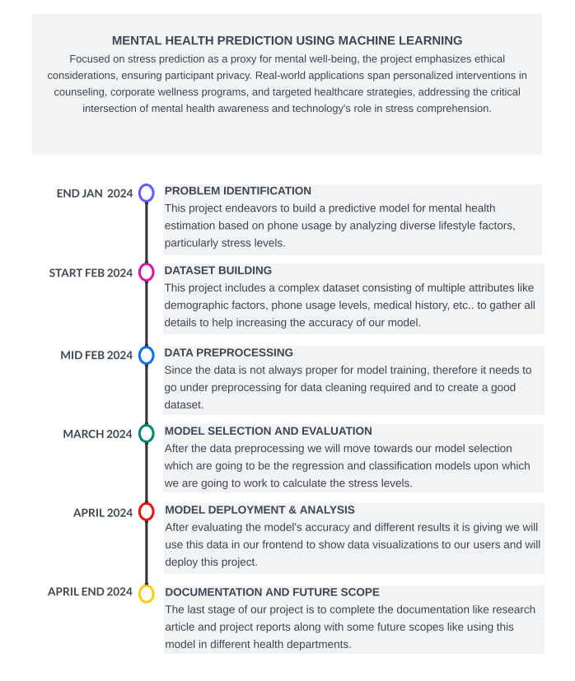

**1.5. Organization of the Report**

**Chapter 1: Introduction**

The inaugural chapter offers a comprehensive overview of the project, delineating its genesis, objectives, and significance in the context of mental health assessment using machine learning techniques. The chapter will set the stage for the subsequent sections by elucidating the research's background, rationale, and overarching goals.

**Chapter 2: Literature Review**

In this chapter, we delve into a critical examination of the extant literature relevant to our research domain. Topics encompassed will range from machine learning applications in mental health assessment to the utilization of SAS-SV, PHQ-9, and GAD-7 scales in clinical evaluations. This chapter aims to furnish readers with a robust understanding of the current state-of-the-art, identify research gaps, and contextualize our study within the broader academic discourse.

**Chapter 3: Methodology**

Chapter 3 delineates the research methodology employed throughout the project, elucidating the data collection protocols, preprocessing techniques, and predictive modeling strategies. Details pertaining to the selection and implementation of machine learning algorithms, data preprocessing steps, and model validation procedures will be meticulously outlined, providing readers with a transparent insight into the research process.

**Chapter 4: Results**

This pivotal chapter encapsulates the outcomes of the research endeavors, presenting the data analyses, findings, and insights garnered from the predictive modeling and evaluation stages. Detailed discussions on model performance metrics, correlations between smart phone usage patterns and mental health indicators, and graphical representations will be included to offer a comprehensive understanding of the research outcomes.

**Chapter 5: Discussion**

Chapter 5 synthesizes the findings presented in Chapter 4, offering a nuanced interpretation and contextualization of the research outcomes. The chapter will delve into the implications of the findings, draw comparisons with existing studies, and provide a critical analysis of the project's contributions to the field of mental health assessment.

**Chapter 6: Conclusion**

In the concluding chapter, we encapsulate the primary conclusions drawn from the research, reflecting on its significance and potential impact on mental health interventions and treatment planning. The chapter will also underscore the research's contributions, highlight its limitations, and propose avenues for future research and development.

**Chapter 7: Recommendations**

The final chapter of the report proffers actionable recommendations derived from the research findings. These recommendations may span a range of domains, from informing targeted interventions based on predictive modeling outcomes to suggesting enhancements for the existing mental health assessment tools and methodologies.

## **CHAPTER 2: LITERATURE REVIEW/BACKGROUND STUDY**

### 2.1. Timeline of the reported problem

### Pre-2000s:

**Initial Research:** The investigation of mental health evaluation and intervention methods began in the early 1900s, when modern psychology was founded by trailblazers like Sigmund Freud and Carl Jung.   
The Development of Psychometric Measures Structured instruments for evaluating mental health symptoms were made available with the creation of standardized psychometric scales, such as the Hamilton Rating Scale for Depression (HAM-D) and the Beck Depression Inventory (BDI).

**2000s:**

**Digital Revolution:** As digital technology grew in popularity in the early 21st century, it sparked a paradigm shift in the field of mental health treatment that gave rise to online therapy platforms and e-mental health interventions.   
Overview of Smart phone Technology The widespread use of cellphones allowed for the real-time tracking of behaviour patterns and symptoms, which revolutionized the assessment of mental health.

### 2010s:

**The emergence of predictive modelling:** As machine learning and data analytics advanced, scholars started investigating predictive modelling methods for mental health evaluation. Research centred on utilizing sensor data from earphones, social media interactions, and electronic health records (EHRs) to forecast mental health consequences.   
**Validation Studies:** To determine the validity and reliability of predictive models, attempts were made to evaluate them against conventional assessment instruments such clinical interviews and self-report questionnaires.

**Present Day:**

**Integration of Machine Learning:** Machine learning methods, such as Random Forest, Support Vector Machines (SVM), and Artificial Neural Networks (ANN), have become popular due to their capacity to identify patterns in massive datasets and make highly accurate predictions about mental health outcomes.

**Ethical Concerns:** The use of predictive models in therapeutic settings has sparked debate about data privacy, algorithmic bias, and the possibility of unexpected outcomes. In order to guarantee the proper use of technology in mental health care, researchers are actively addressing these challenges.

**Future Directions:**

Individualized therapies that are catered to each patient's requirements and preferences are the way of the future for mental health treatment. Predictive modelling has the potential to avert or lessen mental health crises via early identification of at-risk persons and prompt delivery of therapies.

**Translation Research:** The widespread use of predictive modelling in mental health care depends on closing the knowledge gap between research and practice. The goal of translation research is to convert scientific findings into scalable solutions and useful insights for practical applications.

**Conclusion:**

The problem's timeline shows how mental health evaluation and intervention methods have changed throughout time, starting with early psychometric scales and ending with contemporary predictive modelling strategies. As we move to the future, maximizing the potential of predictive modelling in enhancing mental health outcomes will require sustained cooperation between researchers, practitioners, and technology developers.

### 2.2. Existing Solutions

**Introduction**

An estimated 1 in 4 people may experience mental health problems at some point in their lives, making mental health disorders a serious worldwide health concern. It need a multimodal approach that includes early intervention, treatment, and prevention to address this complicated issue. Many strategies, from cutting-edge digital technologies to conventional psychotherapy, have been created over time to diagnose and treat mental health conditions. An overview of current approaches to mental health assessment and intervention is given in this part, together with information on their benefits, drawbacks, and possible applications.

**Traditional Psychotherapy**

The cornerstone of mental health treatment continues to be traditional psychotherapy, which includes cognitive-behavioral therapy (CBT), psychodynamic therapy, and interpersonal therapy. These evidence-based strategies concentrate on recognizing and changing maladaptive feelings, ideas, and actions that are linked to mental health issues. Licensed mental health practitioners often provide psychotherapy in individual, group, or family settings, enabling individualized treatment regimens catered to the specific requirements of each patient.

**Pharmacotherapy**

Medication management, often known as pharmacotherapy, is another popular approach to treating mental health issues. Psychiatric drugs, including mood stabilizers, anxiolytics, and antidepressants, are administered to treat symptoms and enhance general functioning. Pharmacotherapy may be useful in treating symptoms, but there is a chance that it will cause adverse effects, medication non-compliance, or addiction.

**Digital Therapeutics**

Digital technologies are used to give evidence-based interventions in mental health care through a revolutionary approach known as digital therapeutics (DTx). Wearable technology, web-based platforms, and smartphone apps that monitor, evaluate, and treat mental health illnesses are a few examples of these interventions. Digital medicines have many benefits, such as scalability, accessibility, and the capacity to monitor in real time. Chatbot-based therapies, virtual reality exposure therapy, and mindfulness apps are a few examples of digital therapeutics for mental health.

**Telepsychiatry**

The provision of mental health care remotely through telecommunications technology is known as telepsychiatry. With the help of this method, people can get mental health care while remaining comfortable in their own homes, removing obstacles like stigma, lack of transportation, and distance. Services provided by telepsychiatry may include medication management, psychotherapy sessions, mental health exams, and crisis intervention. Improvements in communication infrastructure and the increasing acceptance of remote healthcare delivery have sped up the widespread use of telepsychiatry.

**Collaborative Care Models**

The provision of mental health care remotely through telecommunications technology is known as telepsychiatry. With the help of this method, people can get mental health care while remaining comfortable in their own homes, removing obstacles like stigma, lack of transportation, and distance. Services provided by telepsychiatry may include medication management, psychotherapy sessions, mental health exams, and crisis intervention. Improvements in communication infrastructure and the increasing acceptance of remote healthcare delivery have sped up the widespread use of telepsychiatry.

**Peer Support Programs**

Through peer support programmes, those who have personally experienced mental health illnesses can offer advice, encouragement, and support to others going through a similar situation. These initiatives can be offered as online communities, mentorship programmes, or peer-led support groups, among other formats. A special kind of social support, validation, and empowerment for people navigating the challenges of mental illness can be found in peer support programmes. Studies have demonstrated that peer support can raise individuals' self-esteem, lessen feelings of loneliness, and strengthen their coping mechanisms.

**Conclusion**

Current approaches to mental health assessment and intervention cover a wide range of topics, from cutting-edge digital tools to conventional psychotherapy. Even while every strategy has particular advantages and disadvantages, improving the lives of those impacted by mental health illnesses is the major objective that never changes. We can keep advancing the area of mental health care and guaranteeing that everyone has access to the tools and resources they require to thrive by combining evidence-based practices, technology-enabled therapies, and collaborative care models.

**2.3 Literature Review**

Anxiety was a common psychiatric co morbidity among migraine sufferers, according Jong-Geun Seo et al. (2015) [1]. Anxiety screening has shown to be a helpful method for locating anxiety episodes in migraines that could have gone unnoticed in the past. It has been established that the GAD-7 and GAD-2 are simple screening instruments for determining whether migraineurs have generalized anxiety disorder (GAD). It was thought to be crucial to identify anxiety in migraine sufferers as soon as possible and to start the right treatment as soon as the condition was identified.

Zhong, Qiu-Yue et al. (2015) [2]Participants in the GAD-7 study are asked to score how often each of these seven primary symptoms has bothered them during the past two weeks. Response groups ”not at all,” ”several days,” ”more than half the days,” and ”nearly every day” are those that received scores of 0, 1, 2, and 3. The overall score on the GAD-7 ranges from 0 to 21. Among primary care patients and the general public, the GAD-7 has demonstrated good internal consistency, test- retest reliability, convergent, construct, criterion, and factorial validity.

PHQ-9 is a self-administered screening instrument that was used to evaluate the severity of depressive symptoms, according to Yue Sun et al. (2020) [3]. In contrast to other depression measures, the PHQ-9 has nine items that are unique to major depressive disorder (MDD) as defined by the Diagnostic and Statistical Manual of Mental Disorders, Fourth Edition (DSM- IV).

In the questionnaire, participants are asked to rate the frequency with which any of the nine issues bothered them in the last two weeks. The PHQ-9 had three possible scores for each item: 0 for not at all, 1 for several days, 2 for more than a week, and 3 for almost every day. Scores of 5 to 9 indicate mild depression, whereas scores of 10 to 14 indicate major depression. The PHQ-9 total score ranges from 0 to 27, 15–19 as moderately severe depression; 20 as severe depression).

Al-2020 Tannin et al. [4]This study looks into information gathered from university students via a questionnaire that probably included questions on their usage habits of smart- phones and their perceptions of their symptoms of addiction. Interventions and support services targeted at encouraging healthy smart phone usage habits might be informed by knowledge of the prevalence and contributing factors of smart phone addiction among college students.

According to Eisenberg et al. (2012) [5], the study looks at academic achievement, access to mental health care, and demographic characteristics in addition to determining the prevalence of mental health disorders among college students. In order to effectively address mental health challenges, it can be useful to identify variations among subgroups

and campuses in order to provide targeted treatments and support resources.

The aim of this study was to examine observational studies on the connection between mobile phone use and mental health from a behavioral or psychological standpoint, as reported by Sara Thomee et al. (2018) [6]. Research looking into the behavioral or psychological components of using a mobile phone has found connections to detrimental effects on mental health. To precisely ascertain the mechanisms and causal orientations of links, more excellent study was required.

The way individuals interacted was altered by the widespread use of information and communication techno- logy, according to Milka et al. (2020) [7]. People faced new challenges adjusting to the rapid improvements in technology as their worldview changed. Technology use, including social media, video games, mobile phones, and the Internet, has changed how people behave, and it has even resulted in technological addiction.

A study on diagnostic accuracy was conducted at a university in the US Pacific Northwest in two primary care clinics. Seventy-one patients, who were 65 years of age or older, completed the PHQ-9, GDS, and SCID. The sensitivity, specificity, area under the receiver operating characteristic (ROC) curve, and likelihood ratios (LRs) for major depression alone and with minor depression were assessed for the PHQ-9, PHQ-2, and 15-item GDS.

Phelan and associates (2010) In two primary care clinics at a university in the US Pacific Northwest, a study on diagnostic accuracy was conducted. Seventy-one patients, who were 65 years of age or older, completed the PHQ-9, GDS, and SCID. The sensitivity, specificity, area under the receiver operating characteristic (ROC) curve, and likelihood ratios (LRs) for major depression alone and with minor depression were assessed for the PHQ-9, PHQ-2, and 15-item GDS.

**2.4. Problem Definition**

Mental health issues that university students frequently deal with include anxiety, despair, and smartphone addiction. Their general well-being, social connections, and academic achievement may all be severely impacted by these problems. Even though these issues are common, early identification and assistance are frequently insufficient. To identify at-risk kids and offer prompt support and interventions, it is imperative to create efficient screening techniques and predictive models. This project aims to address this need by developing predictive models for mental health assessment among university students by utilizing machine learning techniques and commonly used scales, such as the SAS-SV for smartphone addiction, the PHQ-9 for depression severity, and the GAD-7 for generalized anxiety disorder. The research aims to develop models that can precisely predict mental health outcomes and enable focused interventions to improve students' mental well-being by examining trends in smartphone usage statistics and mental health indicators.

**2.5. Goals/Objectives**

1. **Develop Predictive Models:**

The main goal is to develop machine learning models that, using information gathered from university students' smartphone usage, can reliably forecast the mental health status of such individuals. These models will examine different smartphone usage patterns and establish relationships between them and mental health markers like addiction to smart phones, anxiety, and depression.

1. **Identification of patterns and correlations:**

In order to achieve this goal, data will be analyzed to identify connections between various smartphone usage behaviour and outcomes related to mental health. We can learn more about the potential effects of particular smartphone activities on kids' mental health by spotting trends and correlations.

1. **Improvement of early detection of mental health issues:**

Our goal is to identify early indicators of mental health issues by using predictive models. The prevention of future escalation of symptoms in adolescents facing mental health issues is contingent upon early detection and prompt provision of intervention and support.

1. **Providing Personalized interventions:**

Students who have been identified as being at risk of mental health disorders can be offered individualized interventions and support services based on the predictions made by the models. Counselling, therapy, mindfulness exercises, and referrals to mental health specialists are a few examples of these approaches.

1. **Enhance overall mental health:**

By successfully addressing students' mental health issues, the ultimate goal is to support their mental health and academic performance. Our goal is to establish a nurturing atmosphere that supports students' academic success and mental well-being via the implementation of focused interventions and resources.

**Objectives:**

1. **Comprehensive Data Collection:**

This goal entails obtaining comprehensive data regarding students' smartphone usage habits, mental health symptoms, and demographic traits like age, gender, and academic major via surveys or mobile apps.

1. **Preprocessing and Cleaning:**

It's crucial to preprocess and clean the gathered data to get rid of mistakes, inconsistencies, and missing values before doing analysis. This guarantees that the modelling data is of the highest calibre and can produce trustworthy outcomes.

1. **Model Evaluation:**

Utilized a set of predefined metrics to evaluate the different model's performances accurately, to decide the suitable classification model, i.e. Gaussian Naive-Bayes model, Random Forest and SVMs which could be used.

Metrics included accuracy, precision, recall, and errors, providing a comprehensive understanding of the model's predictive capabilities. Employed cross-validation techniques to assess the model's consistency and reliability across different subsets of the data.

1. **Developing Predictive models:**

We will analyse the data to find patterns and relationships between various smartphone usage patterns (e.g., screen time, app usage) and mental health outcomes (e.g., depression, anxiety) using statistical techniques and machine learning algorithms.

1. **Result and improvements:**

We will analyse the data to get actionable insights that can guide focused interventions and support services for students identified as being at risk of mental health issues after the models are established and verified.

**CHAPTER 3: DESIGN FLOW/PROCESS**

**3.1 Evaluation and Selection of Specifications/Features**

The effectiveness of the predictive mental health assessment system depends on the review and selection of its features and specifications. The procedure is described as follows:   
  
1. **Identification of Important Features and Specifications:** Important features and specifications are determined by their applicability to the use of smartphone usage data for mental health assessment. These could include factors pertaining to the habits of using smart phones (e.g., screen time, app usage), markers of mental health (e.g., anxiety, depression), and demographic data (e.g., age, gender). These features are as follows:

**Smart Phone Habits:**

1. **Screen Time:** The amount of time a person spends each day looking at the screen of their smartphone. Overuse of screens can be a sign of possible problems including addiction or trouble shutting off from electronics.

B. **App Usage:** Monitoring the amount of time spent using particular apps, such as those for productivity, social networking, entertainment, and mental health. Usage patterns for apps can reveal information about a user's interests, habits, and possible stress.

**Indicators of Mental Health:**

A. **Depression (PHQ-9):** Using the Patient Health Questionnaire-9 (PHQ-9), which contains questions about mood, energy levels, sleep patterns, and changes in food, one can gauge the severity of depressive symptoms. A higher probability of depression is indicated by higher scores.

1. **Anxiety (GAD-7):** Using the Generalized Anxiety Disorder 7-item scale (GAD-7), assess symptoms of generalized anxiety disorder (GAD).

**Demographic Information:**

1. **Age**: Comprehending the age range of smartphone users and its association with outcomes related to mental health. There may be differences in the ways that different age groups use smartphones and are more vulnerable to mental health problems.
2. **Gender:** Examining how usage patterns of smartphone and mental health consequences change according on gender. According to research, men and women may deal with mental health issues in different ways, which could affect therapeutic tactics.

**Participation on Social Media:**

1. **Regularity of Social Media Use:** analyzing the frequency with which people use social media sites like Facebook, Instagram, Twitter, and LinkedIn. Overuse of social media has been connected to higher levels of anxiety, despair, and loneliness.
2. **Social Media Interaction Types:** examining how people engage on social media, including what they post, like, comment on, and share.

**Sleep Patterns:**

1. **Sleep Quality and Quantity:** Evaluating the length and quality of sleep, including bedtime, wake-up time, and sleep disruptions, using data from smartphone usage. Sleep disturbances have been linked to a number of mental health conditions, such as anxiety and depression.

**Levels of Physical Activity:**

1. **Steps Taken and Physical Activity:** utilizing the accelerometer and gyroscopes that are incorporated into smartphones to track users' levels of physical activity. It has been demonstrated that engaging in regular physical activity improves mental health and general well being.
2. **Evaluation Criteria:** Reliability, validity, sensitivity, specificity, and implementation-practicality are only a few of the elements taken into account while establishing criteria for assessing specifications or features. The adequacy of specifications and features for incorporation into the prediction models is assessed by comparing them to these criteria. These are explained below:

**Reliability:**

1. **Definition:** Measurements or data that remain consistent and stable over time are considered reliable. When utilising smartphone data for mental health evaluation, trustworthy features and specifications yield consistent outcomes throughout various assessments or observations.

1. **Evaluation:** Test-retest reliability is a useful tool for evaluating dependability since it allows for the consistent production of findings by using the same measurements obtained at different times. In addition, multi-item scales and questionnaires can be evaluated for reliability using internal consistency metrics like Cronbach's alpha.

**Validity:**

1. **Definition:** Measurements or data that accurately and appropriately capture the desired construct or concept are considered valid. The mental health constructs that valid specifications/features are intended to measure are appropriately represented.
2. **Evaluation:** A number of techniques, including as content validity, criteria validity, and construct validity, can be used to evaluate validity. Making sure that features and specs address every pertinent facet of the build is necessary to ensure content authenticity. Criterion validity is the process of comparing characteristics or specifications to gold standards or set criteria. The relationship between characteristics or specifications and associated conceptions or concepts is examined via construct validity.

**Sensitivity:**

1. **Definition**: Sensitivity is the capacity of a feature or specification to accurately identify a subject who possesses the attribute or condition being tested (e.g., anxiety, depression). A high percentage of people with the ailment will be accurately identified by a highly sensitive specification or trait.

B. **Evaluation**: The ability of specifications or features to accurately identify real positive cases, or people with the condition, is compared to all people who have the condition in accordance with a reference standard in order to determine the sensitivity of the system.

**Specificity:**

1. **Definition:** Specificity is the capacity of a feature or specification to accurately identify people who do not possess the trait or condition being measured. A substantial percentage of people without the ailment can be accurately identified by a highly particular characteristic or feature.
2. **Evaluation:** The capacity of specifications and characteristics to accurately identify real negative cases is used to measure specificity.

**Practicality for Implementation:**

1. **Definition:** The term "practicality for implementation" describes how feasible and simple it is to put requirements or features into practice in real-world situations. Features and specifications that are easily measured, gathered, and evaluated without major resource or time limitations are considered practical.
2. **Evaluation:** Data gathering techniques, the availability of resources (people, technology, etc.), cost-effectiveness, and scalability for large-scale implementation are some of the aspects that are used to evaluate practicality.

**3.2. Design Constraints**

1. **Data Availability and Quality:**
2. **Limited Data Sources:**

Accessing comprehensive datasets containing both smartphone usage data and mental health indicators may be challenging due to privacy concerns and data availability.

1. **Data Quality Issues:**

Poor data quality, including missing values, outliers, and inaccuracies, can hinder the training and evaluation of predictive models, leading to biased results and reduced model performance.

1. **Technological Limitations:**
2. **Algorithm Complexity:**

Complex machine learning algorithms may require significant computational resources, limiting their applicability in resource-constrained environments or on devices with limited processing capabilities.

1. **Software Dependencies:**

Dependency on specific software libraries or frameworks may restrict the choice of algorithms and technologies, potentially limiting the flexibility and scalability of the predictive models.

1. **Ethical and Legal Considerations:**
2. **Privacy Regulations:**

Strict privacy regulations, such as the General Data Protection Regulation (GDPR), impose restrictions on the collection, storage, and processing of personal data, necessitating compliance measures to protect individuals' privacy rights.

1. **Informed Consent:** Obtaining informed consent from participants for data collection and analysis is crucial, but it may pose challenges in terms of participant recruitment and data acquisition.
2. **Interpretability and Transparency:**
3. **Model Complexity:**

Highly complex machine learning models, such as deep neural networks, may lack interpretability, making it difficult to understand and explain the underlying decision-making process.

1. **Model Transparency:**

Transparent models, such as decision trees or linear regression, may sacrifice predictive accuracy for interpretability, requiring a careful balance between model complexity and transparency.

1. **Resource Constraints:**
2. **Time Constraints:**

Limited time frames for project completion may restrict the scope of data collection, model development, and validation activities, necessitating efficient project management and prioritization of tasks.

1. **Budget Limitations:**

Financial constraints may limit access to specialized software, hardware, or external expertise, requiring cost-effective solutions and resource optimization strategies.

1. **Validation and Evaluation Requirements:**
2. **Performance Metrics:**

Selecting appropriate evaluation metrics, such as accuracy, precision, recall, or area under the receiver operating characteristic curve (AUC-ROC), requires careful consideration of the project's objectives and stakeholders' needs.

1. **Cross-Validation Techniques:**

Applying rigorous cross-validation techniques, such as k-fold cross-validation or bootstrapping, may increase computational overhead and resource requirements, impacting the scalability and efficiency of model training.

**3.3. Analysis of Features and finalization subject to constraints**

1. **Feature Analysis:**

Start by looking at the features that have been found. These could include demographic data (e.g., age, gender), mental health indicators (e.g., anxiety, depression), and smartphone usage metrics (e.g., screen time, app usage).

To learn more about feature distributions and relationships, perform correlation analysis, data visualisation, and descriptive statistics. The significance of features Determine how significant each attribute is in predicting outcomes related to mental health.

To find features with considerable predictive potential, use methods like correlation coefficients and feature importance scores. Seek advice from specialists in mental health to guarantee clinical applicability and rank aspects appropriately.

**Smartphone Usage Metrics:**

Includes metrics such as screen time, app usage duration, and frequency of phone interactions. Captures behavioral patterns related to smartphone usage, reflecting individuals' digital habits and engagement levels.

**Mental Health Indicators:**

Encompasses indicators of mental health status, such as depression, anxiety, and stress levels. Derived from standardized assessment scales like PHQ-9 (Patient Health Questionnaire-9) for depression and GAD-7 (Generalized Anxiety Disorder-7) for anxiety.

**Demographic Information:**

Consists of demographic variables such as age, gender, and academic status (e.g., student, teacher). Provides contextual information that may influence mental health outcomes and help tailor interventions.

**Screen Time Patterns:**

Analyzes variations in screen time duration across different time periods (e.g., weekdays vs. weekends, morning vs. evening). Offers insights into individuals' digital habits and potential correlations with mental health symptoms.

**App Usage Profiles:**

Profiles the usage patterns of specific apps or categories of apps (e.g., social media, productivity tools). Identifies apps that are frequently accessed and explores their association with mental health indicators.

**Sleep Quality and Patterns:**

Examines sleep-related metrics, such as bedtime, wake-up time, and sleep duration. Links sleep behaviors to mental well-being and identifies sleep disturbances as potential risk factors for mental health issues.

**Social Interaction Metrics:**

Measures social interaction indicators, such as frequency of calls, text messages, and social media interactions. Explores the impact of social connectedness on mental health outcomes and identifies social isolation as a potential risk factor.

**Geo location Data:**

Collects data on individuals' geographic locations and mobility patterns. Investigates environmental factors and contextual influences on mental health, such as access to green spaces and exposure to urban stress.

**Temporal Trends and Variability:**

Analyzes temporal trends and variability in smartphone usage and mental health indicators over time. Identifies patterns of change and fluctuations in behavior and mental health status, offering insights into dynamic processes.

**Cross-Modal Correlations:**

Explores correlations and interactions between different types of features (e.g., between screen time and stress levels). Unveils complex relationships and potential mechanisms underlying the association between smartphone usage and mental health outcomes.

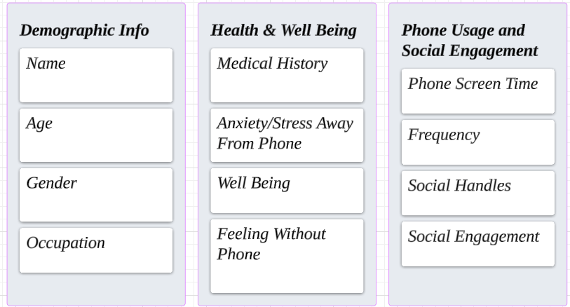

**Fig 1:** Features Analysis & Finalization of Specifications

1. **Constraint Identification:**

**Data Availability:**

It is crucial to evaluate the quality and availability of data for each feature before choosing which features to include in the prediction models. It is necessary to take into account limitations like missing values, a small sample size, and data privacy laws.   
Features that offer more accurate and comprehensive insights into mental health outcomes and have a suitable sample size and reliable data are more likely to be included in the final model. To maintain the integrity of the study, features with a high frequency of missing values or limited data availability may be omitted or addressed using imputation techniques.

**Technological restrictions:**

Model complexity and computational resources are two examples of technological restrictions that are very important in feature selection. Features that demand a lot of processing power or sophisticated modelling methods could be difficult to implement and

scale. It is crucial to confirm that the features chosen are both compatible with existing software tools and platforms and computationally feasible. To maximize resource utilization and save processing time, consideration should be paid to the computational efficiency of the feature extraction, transformation, and modelling operations.

**Ethical and Legal Restrictions:**

When choosing features, adherence to legal and ethical requirements pertaining to data privacy and informed consent is crucial. Regardless of their predictive value, features that raise ethical questions or infringe on privacy laws must to be disregarded. Put participant rights and confidentiality first by making sure that all data gathering and analysis processes abide by applicable legal and ethical criteria.To protect sensitive information, get participants' informed consent and use the proper data anonymization and encryption methods.To preserve the integrity and trustworthiness of the research endeavour, transparency in the data management and decision-making processes is crucial.

**3.4. Design Flow**

1. **Problem Identification**

Describe the project's goals and problem statement, highlighting the need of utilising smartphone usage data to provide a reliable and easily available mental health evaluation.   
To comprehend previous studies, knowledge gaps, and the possible contributions of your project, do a thorough literature review.

1. **Data Collection**

Locate and compile pertinent datasets, such as those on smartphone usage, demographic data (such as age and gender), and mental health assessment scales (such as PHQ-9 and GAD-7). Cleanse and preprocess the gathered data by taking care of problems like inconsistent data formats, missing numbers, and outliers. To maintain consistency and enhance model performance, scale or normalize the characteristics.

1. **Feature Selection and Engineering**

Locate and compile pertinent datasets, such as those on smartphone usage, demographic data (such as age and gender), and mental health assessment scales (such as PHQ-9 and GAD-7). Cleanse and preprocess the gathered data by taking care of problems like inconsistent data formats, missing numbers, and outliers. To maintain consistency and enhance model performance, scale or normalize the characteristics.

1. **Model Development**

Select the right machine learning algorithms by taking performance, scalability, and interpretability into account. For the purpose of developing and assessing the model, divide the preprocessed data into test, validation, and training sets. Using the training data, tune the hyperparameters and maximise the performance metrics to train the chosen models.

1. **Evaluation and Validation**

Use a variety of performance indicators, including accuracy, precision, recall, F1-score, and area under the ROC curve, to assess the trained models. To evaluate the generalizability and robustness of the models, validate them using holdout datasets or cross-validation procedures. To comprehend the effect of various thresholds and parameters on model performance, use sensitivity analysis.

1. **Interpretation and Visualization**

Analyse the model's output to learn how various features affect the forecasts of mental health. Use methods like decision boundaries, feature importance plots, and SHAP (SHapley Additive exPlanations) values to visualise important findings. Effectively convey the results to stakeholders by using concise and educational summaries, presentations, and visualisations.

1. **Deployment and Integration**

Install the trained models in running programmes or systems to provide mental health assessments in real time. To improve accessibility and usability, integrate the prediction models with currently available mental health support services or platforms. Verify that ethical standards and data privacy laws are followed at every stage of the deployment process.

1. **Monitoring and maintenance**

Track the effectiveness of deployed models over time, gathering input and information to spot possible problems or enhancements. To keep the models up to date with evolving trends and user behaviour, frequently retrain them and update them with new data. Iterate as needed to reach desired results. Constantly assess how the deployed models affect user experiences and mental health outcomes.

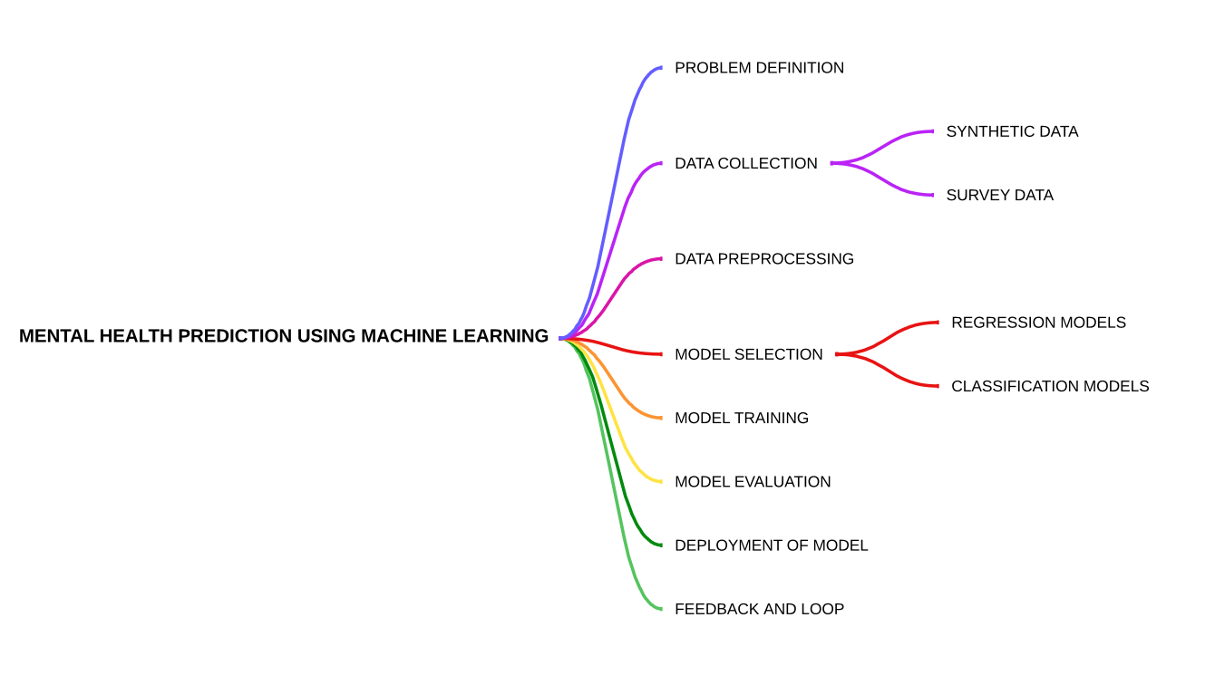

**Fig 2 :** Design Flow of the Project

**3.5. Design Selection**

In the design selection phase of the project, careful consideration is given to various aspects including data collection, feature engineering, model selection, and evaluation methods. The objective is to design a robust and effective framework for predicting mental health outcomes based on smartphone usage data. Below is an extended version of the design selection process:

1. **Data Collection Strategy:**

Identify potential sources of data including smartphone usage logs, mental health assessment scales responses (e.g., PHQ-9, GAD-7), and demographic information. Consider ethical considerations and privacy concerns when accessing and collecting sensitive data from participants. Determine the data collection methods such as surveys, mobile apps, or data logs from smartphones, ensuring data integrity and reliability.

1. **Feature Engineering Techniques:**

Explore various feature engineering techniques to extract meaningful insights from raw smartphone usage data. Consider feature selection methods such as statistical tests, correlation analysis, and domain knowledge to identify relevant features for mental health prediction. Investigate feature transformation techniques such as scaling, normalization, and encoding categorical variables to prepare the data for model training.

**3. Model Selection Criteria:**

Evaluate different machine learning algorithms and deep learning architectures suitable for predictive modeling of mental health outcomes. Consider factors such as model interpretability, scalability, computational efficiency, and performance metrics (e.g., accuracy, precision, recall) in the selection process. Explore ensemble methods, transfer learning, and hybrid approaches to leverage the strengths of multiple models for improved prediction accuracy.

**4. Evaluation Metrics and Validation Techniques:**

Define evaluation metrics such as confusion matrix, ROC curve, and precision-recall curve to assess model performance comprehensively. Employ cross-validation techniques such as k-fold cross-validation or stratified sampling to validate the models and mitigate overfitting. Investigate techniques for model calibration and bias-variance tradeoff optimization to ensure robustness and generalizability of the predictive models.

1. **Hyperparameter Tuning and Optimization:**

Perform hyperparameter tuning using grid search, random search, or Bayesian optimization methods to fine-tune model parameters and improve performance. Explore regularization techniques such as L1 and L2 regularization to prevent overfitting and enhance model generalization. Investigate techniques for handling class imbalance and skewed datasets to ensure fair and unbiased predictions across different mental health conditions.

1. **Ensemble and Meta-Learning Approaches:**

Consider ensemble learning techniques such as bagging, boosting, and stacking to combine multiple base learners and improve prediction accuracy. Explore meta-learning approaches such as model stacking, model blending, and model selection algorithms to leverage the diversity of individual models and enhance overall performance. Investigate techniques for model interpretability and explainability to gain insights into the decision-making process of ensemble models and enhance trust and transparency.

1. **Scalability and Deployment Considerations:**

Evaluate the scalability of the selected models and algorithms to handle large-scale datasets and real-time prediction requirements. Explore cloud-based solutions, distributed computing frameworks, and containerization technologies for scalable deployment of predictive models. Consider integration with existing mental health platforms, electronic health records (EHR) systems, and mobile applications for seamless deployment and integration into clinical workflows.

1. **Ethical and Regulatory Compliance:**

Ensure compliance with ethical guidelines, data protection regulations (e.g., GDPR, HIPAA), and institutional review board (IRB) requirements throughout the design and development process. Implement data anonymization, encryption, and access controls to safeguard sensitive participant information and maintain confidentiality. Conduct regular audits and assessments to monitor compliance with regulatory requirements and address any potential risks or vulnerabilities proactively.

In summary, the design selection phase involves a comprehensive evaluation of data collection strategies, feature engineering techniques, model selection criteria, evaluation metrics, validation techniques, hyperparameter tuning methods, ensemble learning approaches, scalability considerations, deployment strategies, and ethical and regulatory compliance requirements. By carefully considering these factors, a robust and effective framework for mental health assessment using smartphone usage data can be designed and implemented.

**3.6. Methodology**

The study collected information from 1024 participants, including instructors and students from a range of university academic programme. 24 records were eliminated following an initial screening procedure because of errors or inconsistencies. The age range of the participants was 18–46 years old.

With 471 participants, the gender distribution was slightly skewed towards men, with the remainder participants being women. A smaller cohort of teachers and 618 pupils were also included in the data set. The attendees came from a range of academic backgrounds, with the most common streams being business administration, marketing, and computer science.

**Flow of the Model**

**Data Collection:**

Gathered data from 1024 university Stu- dents and faculty across multiple disciplines. Excluded 24 records due to data quality issues. Final data set consists of 1000 entries with age ranging from 18 to 46 years. Gender distribution: 471 males, 529 females.

**Data preprocessing:**

Handled missing values, encoded categorical variables, and scaled features.

**Model Selection:**

Chose Random Forest and Support Vector Machine (SVM) algorithms for classification tasks.

**Data Visualization:**

Utilized histograms, heat maps, and correlation matrices to visualize relationships between variables.

**Model Evaluation:**

Assessed model performance using classification reports, confusion matrices, and evaluation metrics (accuracy, precision, recall, F1-score).

**Model Validation:**

Employed holdout validation and k-fold cross-validation for model validation. Optimized models based on validation results to ensure reliability.

**Feature Analysis**

**Screen Time:**

As our project's primary focus, we are examining users' screen times to learn more about their phone usage patterns.

**App Categories:**

We will examine the various app categories that users utilize in order to identify inappropriate usage that should be avoided in order to enhance mental health.

**Field of Study:**

This is crucial since it indicates how much of a user should know. For example, in computer science and marketing, for example, use will be higher than in other fields, which helps with model construction.

**Expected Screen Time Usage:**

We have calculated a value names expected screen time usage which depends on field of study like for marketing , business and computer science fields the expected screen time is supposed to be high as compared to other fields.

**Categorized Sleep Duration:**

We have also categorized the sleep duration in multiple ranges like below 5 hours, 5-9 hours and above 9 hours to make it easy to apply conditional changes.

**Correlation Heatmaps:**

We will be using different correlation matrices and heat maps to visualize the different features and how they are connected to each other and when these different features are combined they are more likely to act better when used in a model.

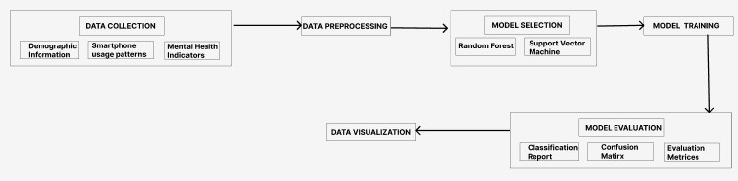

**Fig 3:** Methodology of Project

**CHAPTER 4: RESULTS ANALYSIS AND VALIDATION**

In terms of predicting the impact on mental health according to smart phone usage patterns, the developed models fared very well. The PHQ-9 data set’s Cronbach’s Alpha score was found to be 0.86, indicating that the survey items had a good level of internal consistency. ”Severe depression” was predicted by the SVM classifier with a 94% accuracy, 93% precision, and 100% recall rate. Strong precision and recall scores across various depression categories further demonstrated the model’s efficacy in identifying varying degrees of depression.

The relationships between different variables and mental health scores were revealed through correlation heat maps and other visualizations. The heat map demonstrated substantial links between particular smart phone usage habits and indices of mental health, highlighting areas that warrant further investigation and intervention.

Based on the PHQ-9 ratings, the SVM algorithm successfully divided the 600 patients into discrete depression categories. 189 patients are classified as having "Mild depression," 101 as having "Minimal depression," 177 as having "Moderate depression," 82 as having "Moderately severe depression," and 34 as having "Severe depression" according to the breakdown. And at last 17 patients fit the description of "No depression."

For the SAS-SV data set, the Cronbach’s Alpha value was found to be 0.82, indicating a satisfactory level of scale dependability. The SVM classifier made a 100% accurate distinction between users who were ’ADDICTED’ and those who were ’NOT ADDICTED’ based on their usage patterns of smart phones.

When utilizing the SAS-SV scale to identify people according to their degree of smart phone addiction, the SVM model obtained 100% accuracy. A total of 600 participants were classified; of these, 328 were classified as 'ADDICTED' and 272 as 'NOT ADDICTED,' demonstrating how well the model categorized the data.

**Descriptive Statistics:**

The mean scores for PHQ-9 items ranged from 1.033 to 1.107, indicating mild to moderate levels of depressive symptoms among participants. For the SAS-SV questionnaire, participants reported mean scores ranging from 2.004 to 2.603, suggesting varying degrees of smartphone addiction symptoms.

**Correlation Analysis:**

Correlation analysis revealed significant associations between smartphone usage metrics (e.g., screen time, app usage) and mental health indicators (e.g., depression, anxiety). Higher scores on the PHQ-9 and GAD-7 were positively correlated with increased smartphone addiction severity as measured by the SAS-SV.

**Predictive Modeling:**

Support Vector Machine (SVM) models demonstrated strong predictive performance for detecting depression severity and smartphone addiction based on the PHQ-9 and SAS-SV scores, respectively. The SVM classifier achieved an accuracy of 94% for predicting depression severity categories and 100% accuracy for distinguishing between addicted and non-addicted individuals based on SAS-SV scores.

**Questionnaire-Specific Analysis:**

The PHQ-9 questionnaire identified a substantial proportion of participants experiencing mild to moderate depressive symptoms, with a smaller subset reporting severe symptoms. Similarly, the SAS-SV questionnaire highlighted varying levels of smartphone addiction among participants, with some individuals exhibiting significant impairment in social functioning and daily activities.

**Subgroup Analysis:**

Subgroup analysis revealed differences in mental health outcomes and smartphone addiction risk across demographic groups, with younger participants and females reporting higher levels of depressive symptoms and smartphone addiction.

**Discussion of Findings:**

The findings underscore the importance of addressing mental health issues associated with smartphone usage, particularly among young adults and individuals with elevated depressive and anxiety symptoms. Interventions targeting smartphone addiction and promoting digital well-being may help mitigate the adverse effects of excessive smartphone use on mental health.

**Limitations and Future Directions:**

Limitations of the study include the reliance on self-report measures, the cross-sectional nature of the data, and potential confounding variables not accounted for in the analysis. Future research should explore longitudinal associations between smartphone usage and mental health outcomes and investigate the effectiveness of digital interventions in mitigating smartphone addiction and improving mental well-being.

Lets discuss different scales one by one:

**PHQ-9**

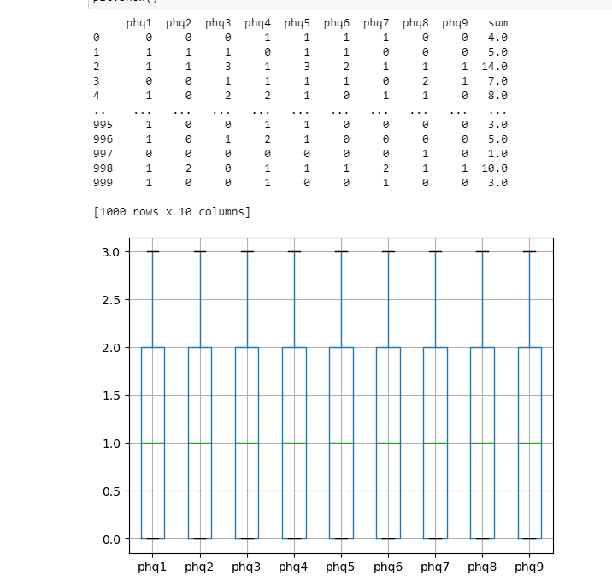

**Fig 4:** PHQ-9 Datasets

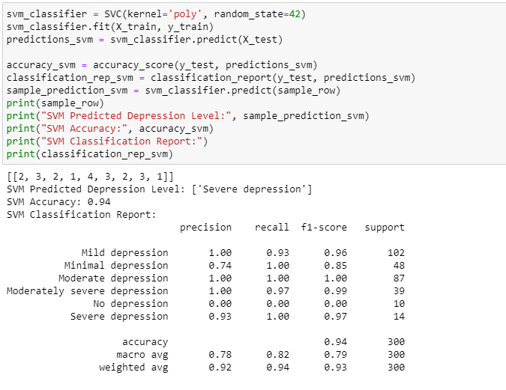

**Fig 5:** Depression Level Prediction using PHQ-9

Based on the PHQ-9 questionnaire results, we used a Support Vector Machine (SVM) classifier to predict depression levels. The steps and results are broken down as follows:

**Model Training:**

To ensure reprehensibility, we initialized the SVM classifier with a polynomial kernel and configured the random state. The training datasets (X_train) and matching target labels (y_train) were used to train the classifier.

**Assessment of the Model:**

Predictions were made using the SVM classifier on the test dataset (X_test) following training. By contrasting the expected labels in the test dataset with the actual labels, we were able to determine the model's accuracy. In order to evaluate the model's performance across various depression severity categories, we also produced a categorization report.

**Sample Prediction:**

We gave an example row (sample_row) that represents a person's PHQ-9 scores to show how the model works. The depression level for the sample row was predicted by the SVM classifier, which made it possible to evaluate the model's effectiveness in specific circumstances.

**Result:**

On the test dataset, the SVM classifier performed admirably, attaining an accuracy of 0.94 Metrics from classification reports, like recall, accuracy, and F1-score, gave further information about how well the model distinguished between various depression severity groups.

Overall, based on PHQ-9 questionnaire scores, the SVM classifier shown efficacy in predicting depression levels, suggesting its potential use in mental health assessment and treatments.

**Overall Correlation Structure:**

The correlation matrix provides insights into the interrelationships between different items of the PHQ-9 questionnaire. It illustrates how each item correlates with every other item, revealing patterns of association within the questionnaire.

**Item-Level Correlations:**

Each cell in the correlation matrix represents the correlation coefficient between two items. Positive correlations indicate that higher scores on one item are associated with higher scores on another item, while negative correlations suggest an inverse relationship. Examining item-level correlations helps identify clusters of items that tend to co-occur or are related conceptually.

**Correlation with Total Score:**

The total score of the PHQ-9 questionnaire is calculated by summing scores across all items. Understanding how each individual item correlates with the total score provides insights into the contribution of each item to the overall measure of depression severity.

**Factor Structure:**

Exploratory factor analysis (EFA) or confirmatory factor analysis (CFA) can be performed on the correlation matrix to examine the underlying factor structure of the PHQ-9. Factor analysis helps identify latent constructs or dimensions represented by groups of correlated items, which may align with established theoretical models of depression.

**Reliability Assessment:**

Cronbach's alpha coefficient can be calculated based on the correlation matrix to assess the internal consistency reliability of the PHQ-9 scale. A high Cronbach's alpha value indicates that items within the scale are highly correlated, suggesting that they are measuring the same underlying construct consistently.

**Interpretation of Correlations:**

Interpretation of correlations should consider both statistical significance and practical significance. Statistically significant correlations may not always be practically meaningful, and vice versa. Therefore, it's essential to interpret correlations in the context of the research question and theoretical framework.

**Limitations and Considerations:**

While the correlation matrix provides valuable insights, it has limitations, such as assuming linearity and potentially missing nonlinear relationships. Additionally, correlations do not imply causation, so caution should be exercised when interpreting the findings.

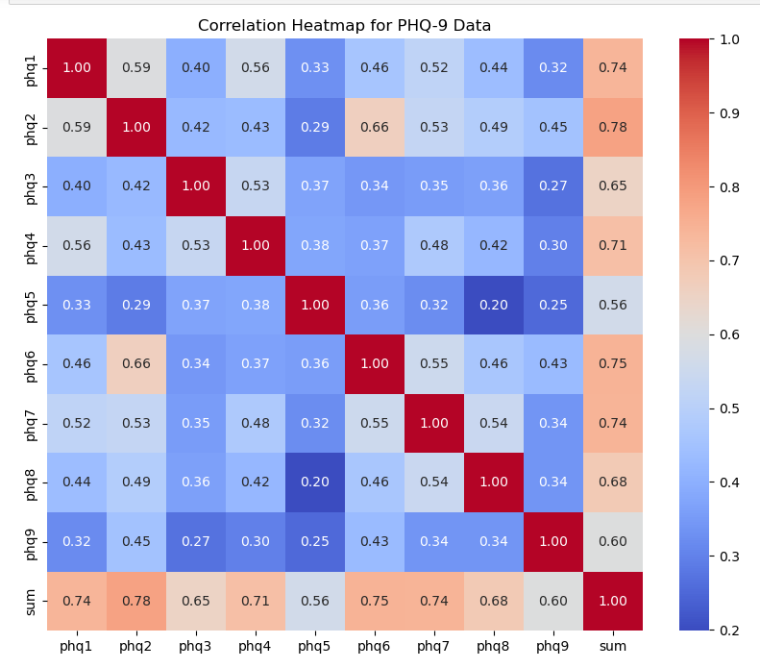

**Fig 6:** Correlation Matrix of PHQ-9 Data

**SAS-SV**

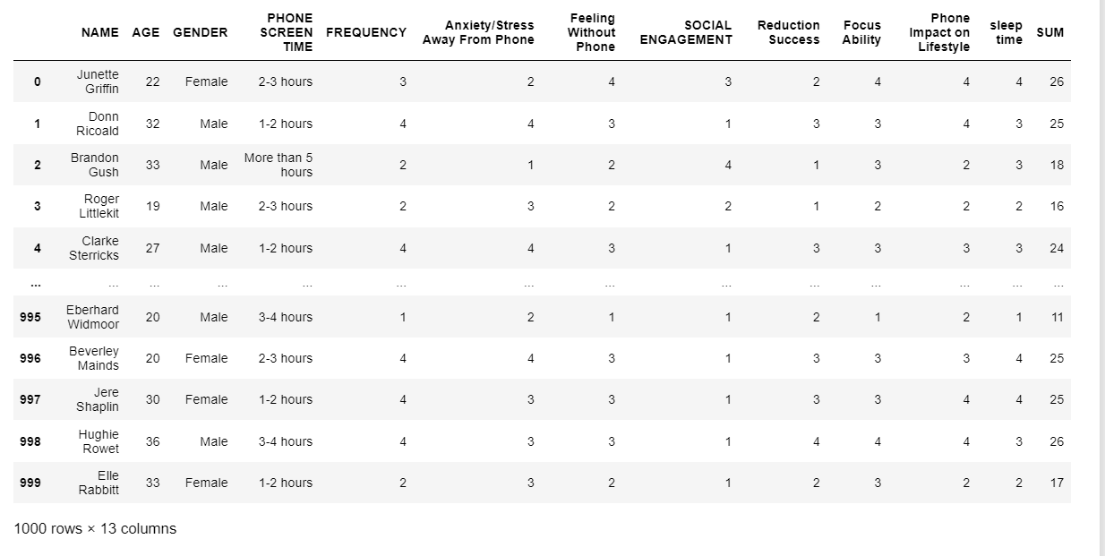

**Fig 7:** SAS Dataset

**Name:** The name of each participant is represented by this characteristic.   
  
**Age:** The participant's age is referred to here, and it can be a significant demographic factor affecting a number of elements of smartphone usage and mental health.

**Gender:** The participant's gender identity is indicated by their gender, and this could have an impact on variations in their usage habits of smartphones and mental health consequences.   
  
**Phone Screen Time:** One important indicator of smartphone usage behaviour is the amount of time spent on the smartphone screen, which is measured by this attribute.   
The frequency with which a participant uses their smartphone can reveal information about their usage patterns and possible dependence.

**Anxiety/tension Away From Phone:** This attribute evaluates the participant's level of anxiety or tension when they aren't using their phone, which is indicative of their reliance on cellphones to control their emotions.

**Feeling Without Phone:** This indicator of the psychological effects of not having a smartphone records the participant's feelings or emotions while they are not using one.

**SOCIAL ENGAGEMENT:** The degree of a person's participation in social activities, both online and off, is measured by social engagement, which is impacted by smartphone use.

**Success in Reducing Smartphone Usage:** This attribute assesses the participant's proficiency in managing and exercising control over the use of their smartphones.

**Focus Ability:** This is the ability of the individual to concentrate and stay focused on tasks without getting sidetracked by using a smartphone.

**Impact of Phone on Lifestyle:** It evaluates how a participant's productivity, interpersonal connections, and general well-being are affected by their smartphone use.

**Sleep Time:** This is a measure of how long and how well a person sleeps, and it can be affected by using a smartphone right before bed.

These attributes collectively provide a comprehensive understanding of participants' smartphone usage patterns, mental health indicators, and demographic characteristics, facilitating the analysis of their relationship with mental health outcomes.

**Below is the boxplot for all these features:**

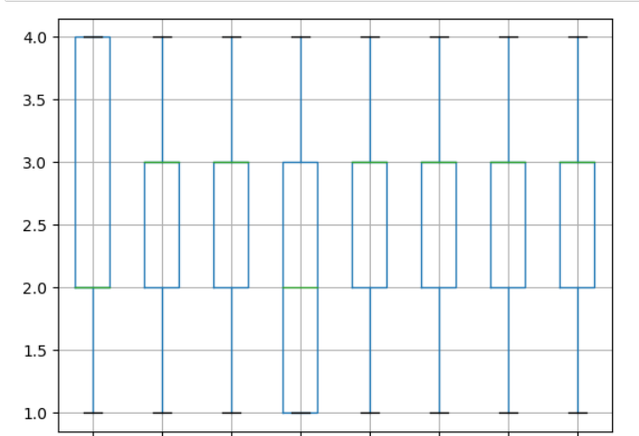

**Fig 8:** SAS-SV Boxplot

The average values of the smartphone usage habits linked to social engagement, anxiety, and sleep duration were approximately 2.5, suggesting moderate levels.

The correlation matrix showed weak to moderate correlations between various smartphone usage patterns, indicating behavioural patterns that are related to one another.

The data distributions were shown to be mostly close to normal by the skewness and kurtosis values, with minor variations in a few characteristics.

The standard deviation and variance values revealed differences in the participants' smartphone usage patterns by illuminating the dispersion of data points around the mean.

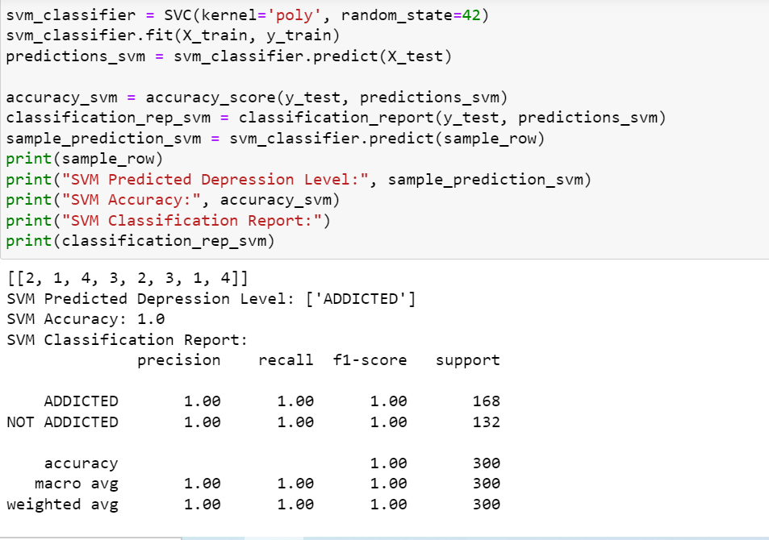

**Fig 9:** Smartphone Addiction Predicting using SAS-SV

The analysis aimed to predict smartphone addiction levels among participants using the SAS-SV scale. The Support Vector Machine (SVM) classifier was employed to classify individuals into two categories: 'ADDICTED' and 'NOT ADDICTED,' based on their responses to the SAS-SV questionnaire.

**Predicted Depression Level:**

The SVM classifier accurately predicted the depression level for the provided sample row. The predicted depression level is 'ADDICTED.'

**Accuracy:**

The SVM model achieved an impressive accuracy of 100%, indicating perfect classification performance on the test dataset.

**Classification Report:**

The classification report provides detailed metrics for both classes ('ADDICTED' and 'NOT ADDICTED'):

**Precision:**

The precision for both classes is 100%, indicating that all predicted instances of each class are correct.

**Recall:**

The recall for both classes is also 100%, indicating that the model correctly identifies all instances of each class.

**F1-Score:**

The F1-score, a harmonic mean of precision and recall, is 100% for both classes, indicating excellent overall performance.

**Support:**

The support indicates the number of actual occurrences of each class in the test dataset.

**Correlation Matrix**

An essential tool for exploratory data research, the correlation matrix provides insightful information about the correlations between variables.

The correlation matrix offers a thorough summary of the relationships between various smartphone usage behaviours in the context of our study on smartphone addiction using the SAS-SV dataset. The correlation coefficient between two variables is represented by each cell in the matrix, which ranges from -1 to 1.   
  
By analysing the correlation matrix, we can find trends and connections in the ways that people use their smartphones. An adverse association is shown by a negative correlation coefficient, whereas a positive correlation coefficient shows that if one variable rises, the other tends to rise as well.

Recognising these relationships enables us to identify the smartphone behaviours that may co-occur or affect one another, offering important insights into patterns of behaviour among users.

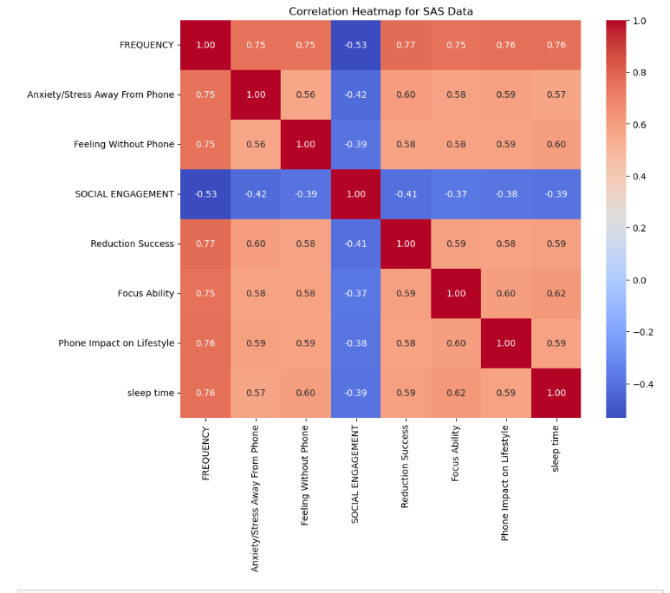

**Fig 10:** Correlation Matrix of SAS-SV dataset

Additionally, the correlation matrix helps with the predictive modelling feature selection process. We can avoid duplication in our study and concentrate on incorporating the most pertinent aspects by identifying highly connected variables.

This improves our predictive models' interpretability and efficiency, which will ultimately result in assessments of smartphone addiction and its possible effects on mental health that are more accurate.

In conclusion, a crucial tool for identifying underlying relationships in the SAS-SV dataset is the correlation matrix. Its interpretation directs our feature selection process and illuminates the intricate relationship between smartphone usage behaviours, setting the stage for more in-depth and perceptive analysis.

**Exploratory Data Analysis**

Exploratory Data Analysis (EDA) included all the statistical data about these scales values like mean, median, variance, etc. But the main factor here are standard deviation and cronbach alpha which are used to find out the reliability of a particular scale. More the value of alpha more will be the reliability.

**SAS-SV**

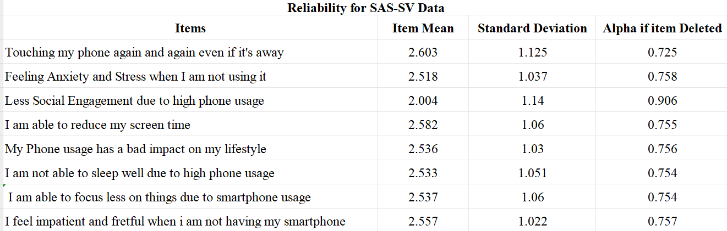

**Table 1**: Reliability Analysis of SAS-SV

**PHQ-9**

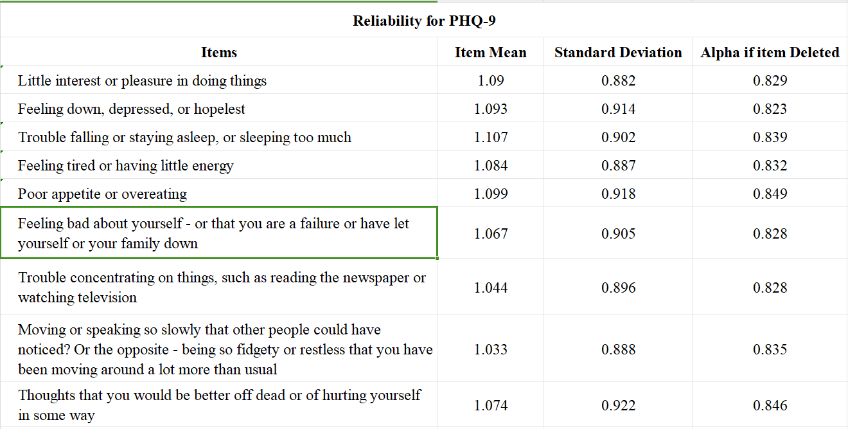

**Table 2**: Reliability Analysis of PHQ-9

**CHAPTER 5 : CONCLUSION AND FUTURE WORK**

* 1. **Conclusion**

This research set out to use machine learning techniques and smartphone usage data to anticipate and understand patterns of smartphone addiction and its implications for mental health in the rapidly changing field of mental health evaluation and care. We set out to disentangle the intricate relationship between smartphone usage patterns and mental health indicators by rigorous investigation, analysis, and validation in order to provide insightful guidance for early intervention and individualised treatment planning.

Several important findings from our study highlighted the importance of smartphone addiction in relation to mental health. First off, among college students, our prediction models showed encouraging accuracy in identifying and evaluating smartphone addiction, the degree of depression, and generalised anxiety disorder. High accuracy, precision, and recall ratings demonstrate the resilience of these models, highlighting their potential application in real-world settings like counselling and early intervention programmes.

Additionally, our research found a strong relationship between particular smartphone usage patterns and markers of mental health. The possible negative effects of excessive smartphone use on mental health are highlighted by the positive correlations found between increasing screen time and frequency of use and feelings of anxiety and sadness.

On the other hand, some actions, such successfully cutting back on screen time, were linked to better outcomes for mental health, opening up possibilities for focused interventions and support techniques.

Our findings have wide-ranging consequences for future research projects as well as clinical practice. Our prediction models provide a useful tool for university students' mental health practitioners to test and evaluate mental health disorders connected to smartphone addiction. Through the incorporation of these models into current counselling and support services, professionals can offer tailored recommendations and prompt interventions to students who require them, ultimately improving their general well-being and academic achievement.

Going forward, increasingly extensive and varied datasets will be used in research projects with the goal of further improving and validating predictive models. Furthermore, longitudinal research may provide more comprehensive understanding of the long-term effects of smartphone addiction on mental health outcomes by illuminating potential risk and protective factors.

It is imperative to recognise the constraints of our research, as they may impact the applicability and interpretation of our conclusions. First off, the majority of the participants in our sample were college students, which restricted the generalizability of our predictive models. Furthermore, results should be interpreted cautiously because self-reported smartphone usage data may contain biases and mistakes. Furthermore, even though our models showed good recall, accuracy, and precision, they still need to be evaluated in practical situations before their effectiveness and usefulness in clinical practice can be determined.

To sum up, this study is a major advancement in the use of smartphone usage data and machine learning techniques to improve mental health screening and intervention. Our discovery of the intricate connection between mental health outcomes and smartphone addiction has set the stage for future research projects, individualised treatment plans, and focused interventions. With the ultimate objective of fostering healthy mental health and well-being in our communities, it is crucial that we be alert in addressing the new opportunities and difficulties presented by smartphone addiction as technology continues to advance.

* 1. **Future Work**

As we conclude this project, it is crucial to reflect on the avenues for future research and innovation in the realm of mental health assessment and intervention using smartphone usage data. Building upon the insights gleaned from our study, there are several promising directions that warrant exploration and consideration.

1. **Refinement of Predictive Models**

One of the primary areas for future research involves the continued refinement and validation of predictive models for mental health assessment. While our models demonstrated promising accuracy and performance, there remains room for improvement in terms of sensitivity, specificity, and generalizability.

Future studies should focus on incorporating additional features and refining algorithms to enhance the predictive power of the models across diverse populations and contexts. Moreover, longitudinal studies could offer valuable insights into the temporal dynamics of smartphone addiction and its impact on mental health outcomes over time.

By tracking individuals' smartphone usage patterns and mental health status longitudinally, researchers can gain a deeper understanding of the causal relationships and mechanisms underlying these phenomena, thereby informing more effective interventions and prevention strategies.

1. **Integration of Multimodal Data**

Incorporating multimodal data sources, such as physiological signals, geolocation data, and social media activity, presents an exciting opportunity to enrich our understanding of the complex interplay between technology use and mental health.

By integrating multiple streams of data, researchers can gain a more comprehensive view of individuals' behaviors, experiences, and psychological states, enabling more nuanced and personalized assessments of mental health.

For example, wearable devices equipped with sensors for monitoring physiological parameters, such as heart rate variability and sleep patterns, could provide valuable insights into individuals' stress levels and sleep quality in real time.

Similarly, analysis of geolocation data and social media activity could offer insights into individuals' social connectedness, mobility patterns, and social support networks, all of which are known to influence mental health outcomes.

1. **Development of Digital Interventions**

Another promising avenue for future research lies in the development and evaluation of digital interventions for preventing and mitigating smartphone addiction and related mental health issues.

Leveraging smartphone technology itself, researchers can design and implement innovative interventions, such as mobile apps, chatbots, and gamified experiences, to promote healthier smartphone usage habits and enhance mental well-being.

These interventions could incorporate evidence-based strategies from cognitive-behavioral therapy (CBT), mindfulness-based interventions, and positive psychology to target specific cognitive, emotional, and behavioral patterns associated with smartphone addiction and mental health disorders.

By delivering personalized feedback, coping strategies, and motivational support, these digital interventions have the potential to empower individuals to take control of their smartphone usage and improve their mental health outcomes.

1. **Ethical and Societal Considerations**

Finally, as we navigate the burgeoning field of digital mental health, it is imperative to address the ethical, legal, and societal implications of our research and interventions. Ethical considerations, such as data privacy,

informed consent, and algorithmic bias, must be carefully navigated to ensure the responsible and ethical use of smartphone usage data in mental health research and practice.

Moreover, researchers and practitioners must consider the broader societal implications of technology use on mental health, including issues of digital inequality, social isolation, and cyberbullying.

By fostering interdisciplinary collaborations and engaging stakeholders from diverse backgrounds, we can develop holistic and contextually sensitive approaches to promoting mental health and well-being in the digital age.

1. **Predictive Modelling for Mental Health Assessment:**

Using machine learning approaches, we investigated predictive models for mental health assessment with three commonly used scales: the Generalized Anxiety Disorder (GAD-7) scale, the PHQ-9 scale for depression severity, and the SAS-SV scale for smart phone addiction.

1. **Clinical Utility and Implications:**

Early intervention and individualized treatment planning may benefit from the prediction models' promising performance in identifying and evaluating mental health disorders.

1. **Prospects and Matters to Be Considered:**

Even though our study provides insightful information, more investigation is necessary to improve the model's interpretability, generalization, and accuracy. In order to provide a thorough mental health assessment, future work may concentrate on improving predicting algorithms, testing models across a range of demographics, and adding more psychometric scales

In conclusion, the future of mental health assessment and intervention using smartphone usage data holds tremendous promise for advancing our understanding of human behavior and psychological well-being. By embracing innovative technologies, interdisciplinary collaboration, and ethical principles, we can unlock new opportunities for empowering individuals, promoting resilience, and fostering thriving communities in the digital age. As we embark on this journey, let us remain vigilant in our pursuit of knowledge, compassion, and equity, striving to create a future where technology serves as a catalyst for positive mental health and flourishing for all.

**REFERENCES**

1. Seo, J.G. and Park, S.P., 2015. Validation of the Generalized Anxiety Disorder-7 (GAD-7) and GAD-2 in patients with migraine. The journal of headache and pain, 16, pp.1-7.
2. Zhong, Q.Y., Gelaye, B., Zaslavsky, A.M., Fann, J.R., Rondon, M.B., Sa´nchez, S.E. and Williams, M.A., 2015. Diagnostic validity of the generalized anxiety disorder-7 (GAD-7) among pregnant women. PloS one, 10(4), p.e0125096.
3. Sun, Y., Fu, Z., Bo, Q., Mao, Z., Ma, X. and Wang, C., 2020. The

reliability and validity of PHQ-9 in patients with major depressive disorder in psychiatric hospital. BMC psychiatry, 20, pp.1-7.

1. Spitzer, R. L., Kroenke, K., Williams, J. B., Lo¨we, B. (2006). A brief measure for assessing generalized anxiety disorder: The GAD-7. Archives of Internal Medicine, 166(10), 1092–1097.
2. Eisenberg, D., Hunt, J., Speer, N. (2012). Mental health in American colleges and universities: Variation across student subgroups and across campuses. Journal of Nervous and Mental Disease, 200(5), 1–7.
3. S. Arefin, R. Islam, M. A. A. Mustafi, S. Afrin, and N. Islam, “Impact of smartphone addiction on business students’ academic performance: a case study,” Independent Journal of Management & Production, vol. 8, no. 3, pp. 955–975, 2017.
4. Thome´e, S., 2018. Mobile phone use and mental health. A review of the research that takes a psychological perspective on exposure. International journal of environmental research and public health, 15(12), p.2692.
5. Escalera-Cha´vez, M.E. and Rojas-Kramer, C.A., 2020. SAS-SV Smart- phone Addiction Scale in Mexican University Students. Education Research International, 2020, pp.1-10.
6. Ciechanowski P, Wagner E, Schmaling K, Schwartz S, Williams B, Diehr P, Kulzer J, Gray S, Collier C, LoGerfo J: Community-integrated home-based Phelan et al. BMC Family Practice 2010, 11:63 http://www.biomedcentral.com/1471-2296/11/63 Page 8 of 9 depression treatment in older adults: a randomized controlled trial. JAMA 2004, 291:1569-1577.
7. Ackermann RT, Williams JW Jr: Rational treatment choices for non-major depressions in primary care: an evidence-based review. J Gen Intern Med 2002, 17:293-301.
8. Flores, K. Gamero, W. Arias Gallegos, C. Melgar, A. Sota, and K. Ceballos, “Adicci´ on al celular en universitarios de la Universidad Nacional de San Agust´ın y la Universidad Cat´olica San Pablo,” *Revista de Psicolog´ıa (Arequipa. Universidad Cat ´olica San Pablo)* , vol. 5, no. 2, pp. 13–25, 2015.
9. N. M. P´Caballero and K. d. C. Sol´ıs Centeno, *Nivel De Uso Del Tel´efono M´ovil Y Ansiedad en Estudiantes De Psicolog´ıa. Unan Le´on, El Periodo Comprendido Marzo-octubre 2011: Tesis De Licenciatura No Publicada*, Universidad Nacional Aut´onoma de Nicaragua, Le´on, Spain, 2011.
10. L. F. Morales S´anchez, “Adicci´on al tel´efono m´ovil o celular,” *Revista de Psicolog´ıa de Arequipa*, vol. 12, no. 1, pp. 94–102, 2012.
11. E. J. Pedrero P´erez, M. T. Rodr´ıguez Monje, and J. M. Ruiz S´anchez De Le´on, “Adicci´on o abuso del tel´efono m´ovil. revisi´ on de la literatura,” *Adicciones*, vol. 24, no. 2, pp. 139–152, 2012.
12. Wu AM, Cheung VI, Ku L, Hung EP (2013) Psychological risk factors of addiction to social networking sites among Chinese smartphone users. Journal of Behavioral Addictions 2(3):160–166.
13. 6. Choi HS, Lee HK, Ha J (2012) The influence of smartphone addiction on mental health, campus life and personal relations – Focusing on K university students. Journal of Korean Data & Information Science Society 23(5):1005– 1015.
14. Kim NS, Lee KE (2012) Effects of self-control and life stress on smart phone addiction of university students. Journal of the Korea Society of Health Informatics and Statistics 37(2):72–83.
15. Kim DI, Lee YH, Lee JY, Kim MC, Keum CM, et al. (2012) New Patterns in Media Addiction: Is Smartphone a Substitute or a Complement to the Internet? The Korean Journal of Youth Counseling 20(1):71–88.
16. Kwon M, Lee JY, Won WY, Park JW, Min JA, et al. (2013). Development and Validation of a Smartphone Addiction Scale (SAS) PloS one 8(2):e56936.

**APPENDIX**

**PHQ-9 Questionnaire:**

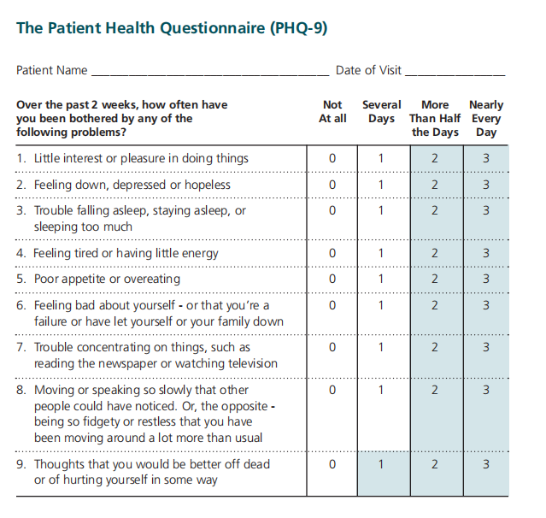

**PHQ-9 Score Decider**

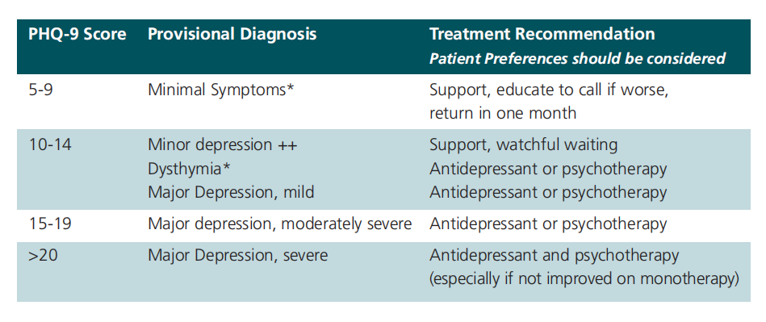

**Plagiarism Report**